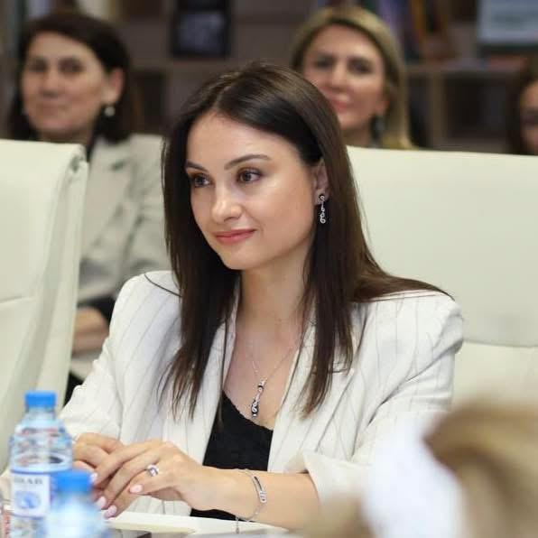
Curriculum Vitae
Name:/ Ad və Soyad | Hasanova Jamila
Date of birth:/ Doğum tarixi | 12.06.1985
Address:/Ünvan | Baku city, Nasimi district, A.Salamzade 53A, m.24
Phones:/ Ev telefonu | +99412 5305930
Mobile:/ Mob telefon | +99450 2368666
E-mail: | hasanovacemile@mail.ru  cemile.hasanova@unec.edu.az
Nationality:/ Milliyəti | Azerbaijani
Citizenship: Vətəndaşlığı | Citizen of Azerbaijan
Marital Status:/ Ailə vəziyyəti | Married
Objective:/Məqsəd | To teach the new generation history, culture, art, and archeology
Education:/Təhsil | 2003-2007- BSU, Faculty of History, bachelor  2007-2009- ADPU, Faculty of History, Master's degree  2012-2017- Institute of Archeology and Ethnography of ANAS, Doctor of Philosophy in History  2021-International Certificate in Social Research Methods and Academic Writing at ADA University  2022 - Holder of Israel's Soft Skills Instructor training certificate
Elmi fəaliyyət:/kurslar, sertifikatlar | In 2008, I started working as a Lobarant at the "History of Azerbaijan" department of UNEC. In 2010, I became a teacher in that department, and since 2017, a senior teacher, since 2016, I have been teaching in Sabah groups at various universities, and since 2019, I have been working as a part-time senior teacher at ASOIU.
Specialty Grade:/Xüsusi dərəcə | The Doctor of Philosophy in History
Work Experience:/ İş təcrübəsi | 16 year
Languages Skills:/ Dil bilgisi | Russian, Turkish, English
Computer Skills:/ Kamputer bilgisi | Microsoft Office
Hobby:/Hobbi | Swimming
Qualifications:/Vəzifə | Senior lecture

